CODING ASSIGNMENT-2

ME 674-SOFT COMPUTING



**SUBMITTED BY-**

ANGSHUMAN NEOGI (214103302)

MTECH, FLUID & THERMAL ENGINEERING

INDIAN INSTITUTE OF TECHNOLOGY, GUWAHATI

**COURSE INSTRUCTOR:**

PROF.SUKHOMAY PAL

MECHANICAL ENGG DEPT., IITG

**Problem:** To minimise the following function using Genetic Algorithm with Roulette-wheel reproduction scheme, two-point crossover and bit-wise mutation.



Range:

x1: [0, 0.5]

x2: [0, 0.5]

Parameters used for plotting the following graphs:

1. Population size, P= 70 (we can take P=6 also as in que)
2. Crossover probability, Pc= 1
3. Mutation probability, Pm= 0.05(neglected in problem)
4. Number of Generations, gen= 50
5. String length,

Taking desired accuracy, ephsilon= 10^(-6)

Using, String length= log2((ximax-ximin)/ephsilon)

= log2((0.5-0)/10^(-6))

≈20

Therefore, string length of one variable, l = 20

1. Fitness function used,

f= 1/(1+f(x1, x2))

**Graphs**

1. **Max,Min,Average fitness vs Number of Generations**

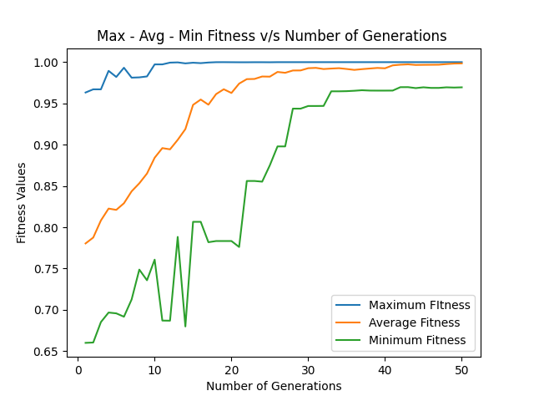

**2.Optimal Solution vs Number of Generations**

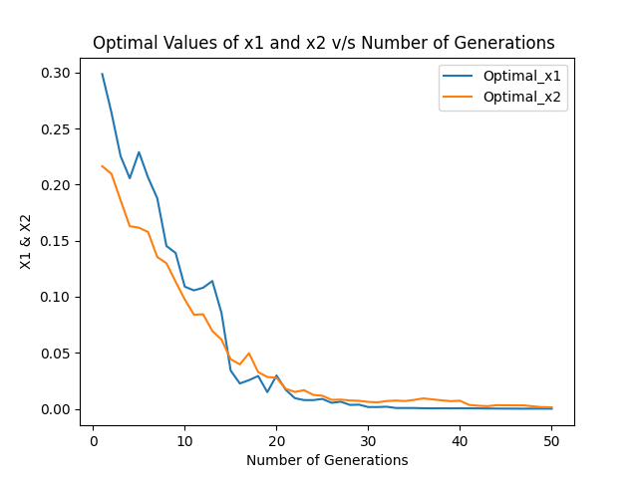

**Results and Conclusion:**

1. The average value of maximisation of the fitness function is coming as 0.97, therefore the average minimum value of the given function is,

f(x1 ,x2)=0.031;

1. The optimal value of x1 and x2 is decreasing with number generations and approaching 0.
2. With increasing value of mutation probability, the solutions are becoming more randomised and hence the graph of average fitness is showing more variations.
3. Increasing the number of population size is decreasing the variations in the average fitness graph.
4. The graphs are flattening at near 50 generations.
5. Keeping the crossover probability high, such as 0.9 is giving better results.

7. Number of Times Mutation is performed : 6980

8. Number of Cross Over Operations : 1750